**Content 41**

**Virtual Base Class In C++**

Virtual base classes are used in virtual inheritance in a way of preventing multiple “instances” of a given class appearing in an inheritance hierarchy when using multiple inheritances.

**Need for Virtual Base Classes:**  
Consider the situation where we have one class **A** .This class is **A** is inherited by two other classes **B** and **C**. Both these class are inherited into another in a new class **D** as shown in figure below.

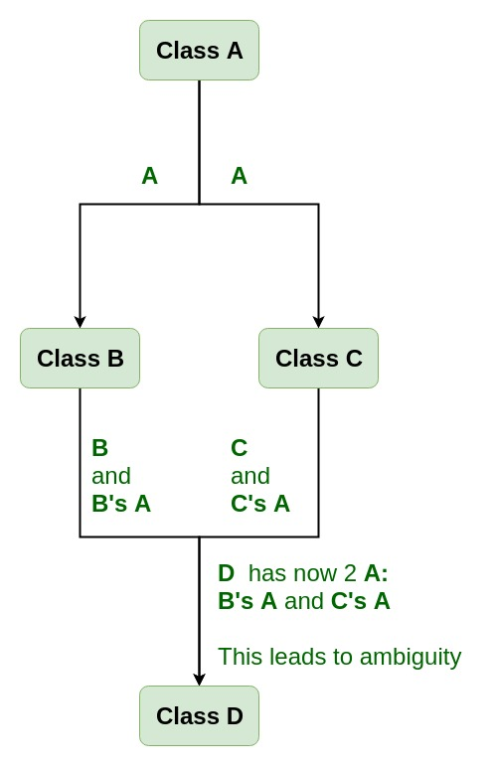

As we can see from the figure that data members/function of class **A** are inherited twice to class **D**. One through class **B** and second through class **C**. When any data / function member of class **A** is accessed by an object of class **D**, ambiguity arises as to which data/function member would be called? One inherited through **B** or the other inherited through **C**. This confuses compiler and it displays error.

#include <iostream>

using namespace std;

class Student

{

protected:

    int roll_number;

public:

    void set_roll(int a1)

    {

        roll_number = a1;

    }

    void display_roll()

    {

        cout << "Roll Number is: " << endl;

    }

};

class Exam : public virtual Student

{

protected:

    float sci_marks;

    float maths_marks;

public:

    void set_marks(float m1, float m2)

    {

        sci_marks = m1;

        maths_marks = m2;

    }

    void display_marks()

    {

        cout << "Marks in Science: " << sci_marks << endl;

        cout << "Marks in MAths: " << maths_marks << endl;

    }

};

class Sports : public virtual Student

{

protected:

    int score;

public:

    void set_score(int s1)

    {

        score = s1;

    }

    void display_score()

    {

        cout << "Score is: " << score << endl;

    }

};

class Result : public Exam, public Sports

{

protected:

    int total;

public:

    void display_result()

    {

        total = maths_marks + sci_marks + score;

        display_roll();

        display_marks();

        display_score();

        cout<<"The Total is: "<<total<<endl;

    }

};

int main()

{   Result r;

    r.set_roll(34);

    r.set_marks(54,41);

    r.set_score(4);

    r.display_result();

    return 0;

}

**Output:**

Roll Number is:

Marks in Science: 54

Marks in MAths: 41

Score is: 4

The Total is: 99

If we remove virtual class from above program then it will through an error.